Chapter 1: Science toolkit

1.1 Science laboratories contain hazards

Student worksheet answers (pages 2–3)

Safety in the laboratory

1 What is a hazard?

Anything that has the potential to put your health and safety at risk

2 What is a chemical hazard?

A chemical that is considered dangerous for a person to touch or inhale

3 What five safety precautions should you follow when working with chemicals?

• A buttoned up lab coat

• Safety glasses

• Long hair tied back

• Closed toed shoes should be worn

• Wear gloves when necessary

4 When observing chemical reactions, what are two things you should never do?

• Never lean over any open containers

• Never breathe in any gases that may be produced

5 What is the correct procedure for smelling any gases produced in a chemical reaction?

Use your hand to gently waft the gas toward your nose

6 Why can’t chemicals be disposed of down the sink?

Some chemicals react with acid traps in drains or are toxic to the environment

7 What should you do if you do not know how to dispose of a chemical?

Ask your teacher

8 Match the hazard symbol to its meaning.

|  |  |  |  |  |  |
| --- | --- | --- | --- | --- | --- |
| 1 | C Substance that may explode if exposed to fire, heat, movement or friction. | 2 | I Substance can cause serious health effects if touched, inhaled or swallowed. | 3 | D Substance that is corrosive (destructive) to living tissues, such as skin and eyes. Also used for substance that is corrosive to metals. |
| 4 | H Substance that catches fire easily. | 5 | A Substance that can cause irritation (redness or rash). | 6 | E Substance is toxic to marine organisms and may cause long-lasting effects in the environment. |
| 7 | F Provides oxygen to make other substances burn more fiercely. | 8 | B Can cause death if touched, inhaled or swallowed. | 9 | G Contains gas under pressure. Released gas may be very cold. Gas container may explode if heated. |

Extend your understanding

9 How would you dispose of the following materials?

a Olive oil

Collect in a bottle and dispose of in regular waste

b Plasticine

Place in regular rubbish

c A dilute acid

Pour down the drain

d A rat in a dissection

Teacher to collect solids; deactivate the liquid with bleach for 30 min and then pour down the drain

e Ammonia (a base – alkali)

Neutralise the alkali (with acid) and pour down the drain

f Untreated Eucalyptus leaves

Place in regular rubbish

1.2 Dissection is an important science skill

Student worksheet answers (pages 4–5)

Dissection

1 What is dissection?

The process of cutting apart and observing something to study it; requires the use of specialised equipment and techniques

2 What are the four main pieces of specialised equipment that is required to perform a dissection?

Scissors, probe, scalpel and forceps/tweezers

3 State the name and function of these four specialised pieces of equipment.

|  |  |
| --- | --- |
|  | Name: Scissors  Function: Used for cutting skin and other tissues. Have rounded tips, which are less destructive to the tissue being cut. |
|  | Name: Probe  Function: Used to look at and explore a specimen, and to probe openings. It takes the place of your fingers, i.e. used for the same purpose. |
|  | Name: Scalpel  Function: Small and extremely sharp steel blade that is used for precision/accurate cutting. Sometimes small incisions can be made with these and scissors are used for the rest. |
|  | Name: Forceps/tweezers  Function: A hinged instrument used for grasping and holding tissues. It can also be used in place of hands. |

4 Why would you wear safety glasses in a dissection?

Just in case you pierce something unintentionally and biological liquid squirts out.

5 Your first dissection may be conducted of the chicken wing, which is outlined on pages 6–7. Complete a flowchart that acts as a step-by-step summary of the method you will follow in the laboratory.

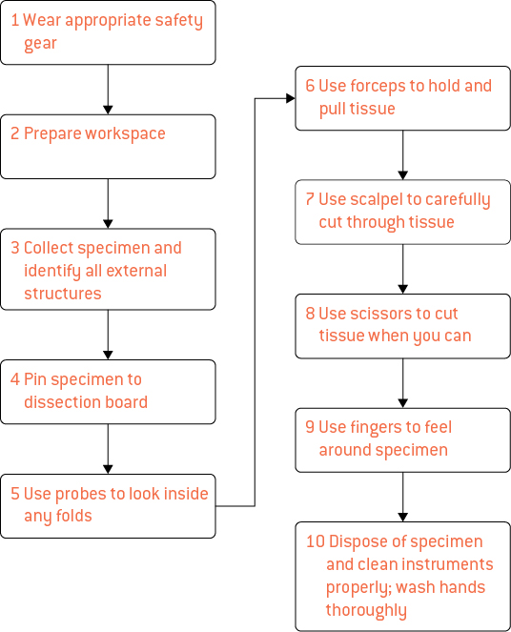

Extend your understanding

6 Elly has completed her frog dissection and is starting to clean up her workbench. She takes off her gloves and lab coat and packs them away. She then washes her hands and heads back to her bench where she picks up her frog and places it on the teacher’s bench with her dissection equipment. After this, she sits down to complete her dissection questions before the bell rings for lunch.

If you were Elly’s teacher, how would you assess her safety? What five recommendations would you make to ensure that Elly is safer in the future?

Assessment

• Elly would not pass, as she has not cleaned her bench or packed up safely.

Recommendations

• Dispose of the frog in the appropriate container or wrap it in newspaper.

• Wash her dissection equipment.

• Use a sponge to wipe down the bench.

• Remove her lab coat and dispose of her gloves.

• Wash her hands.

1.3 Scientists design their own experiments

Student worksheet answers (page 8)

Designing experiments

1 For all of the ‘What if?’ questions on page 8, write a hypothesis and identify the dependant variable, independent variable and three control variables in the spaces below.

a What if the balloon was blown up more?

Hypothesis: If the balloon was blown up more, then the rocket will move further along the string

Dependant variable: The distance that the rocket travels

Independent variable: The amount of gas inside the balloon

Three control variables: Friction between string and straw, balloon shape, balloon material

b What if the string had less friction?

Hypothesis: If the string had less friction, then the rocket will move further along the string

Dependant variable: The distance that the rocket travels

Independent variable: The friction between the straw and the string

Three control variables: Amount of gas in balloon, balloon shape, balloon material

c What if the string had more friction?

Hypothesis: If the string had more friction, then the rocket will not move as far along the string

Dependant variable: The distance that the rocket travels

Independent variable: The friction between the straw and the string

Three control variables: Amount of gas in balloon, balloon shape, balloon material

d What if the straw were shorter?

Hypothesis: If the string was shorter, then the rocket will move further along the string

Dependant variable: The distance that the rocket travels

Independent variable: The size of the straw (and therefore its friction with the string)

Three control variables: Amount of gas in balloon, balloon shape, balloon material

Extend your understanding

2 An experiment was performed where a student dropped a fizzy Alka-Seltzer tablet in 100mL of room temperature water and timed how long it took the tablet to dissolve.

Students were then given four ‘What if?’ questions to investigate the ways to make a chemical reaction go faster.

• What if the water was warmer?

• What if the tablet was crushed into powder?

• What if the tablet was coated in Vaseline?

a In each of the questions, what is the variable that you are testing? What is the name of this variable?

The time it takes to dissolve; the dependant variable

b Name the three factors that you are changing in the above questions.

• temperature

• tablet size/surface area

• tablet surface coating/surface area

c For two of the ‘What if?’ questions above, write a hypothesis and identify the dependant variable, independent variable and three control variables in the spaces below.

Answers will vary.

|  |  |  |  |
| --- | --- | --- | --- |
| Question | What if the water was warmer? | What if the tablet was crushed into powder? | What if the tablet was coated in Vaseline? |
| Hypothesis | If the water was warmer, then the tablet will dissolve faster | If the tablet was crushed into powder, then the tablet will dissolve faster | If the tablet was coated in Vaseline, then the tablet will not dissolve as there is no surface to react with |
| Dependant variable | Time taken to dissolve | Time taken to dissolve | Time taken to dissolve |
| Independent variable | Increased temperature of water | Increased surface area of tablet | Decreased surface area of tablet |
| Three control variables | Surface area of tablet  Volume of water  Shape of reaction vessel | Temperature of water  Volume of water  Shape of reaction vessel | Temperature of water  Volume of water  Shape of reaction vessel |

d After designing your experiment you complete it in the laboratory. The next day, one of your classmates replicates your experiments, but finds that their Alka-Seltzer tablet dissolves faster every time. State one possible reason that this may be happening.

They could be stirring it or the temperature may have increased

1.4 Scientists keep a logbook and write formal reports

Student worksheet answers (pages 10–11)

Logbooks

1 A student writes an entry in their laboratory logbook.

Each section has an error or has not been included. Below, state the errors that the student made.

a Aim

Not thorough and should be put first. It should start by stating ‘To determine …’

b Hypothesis

Is not a prediction of what is expected to happen and should come first (after Aim)

c Method

Is not included (entry Title is also different from that of the practical itself on next page)

d Results

Should be in one table. Third set of data is in Observations, and is not even in a table. Units should only be included in column headings of table. Only three measurements of temperature were taken.

e Observations

Should include the graph and more detailed observations, including any potential errors, etc.

f Conclusion

Is not a reflection based on the volume of water and time taken to boil – too general.

Extend your understanding

2 Use the incorrect logbook entry on the previous page and re-write it in the lined logbook on the following page to show what it should look like. Assume that the experiment below is the one that this logbook entry was based on.

Correct logbook entry:

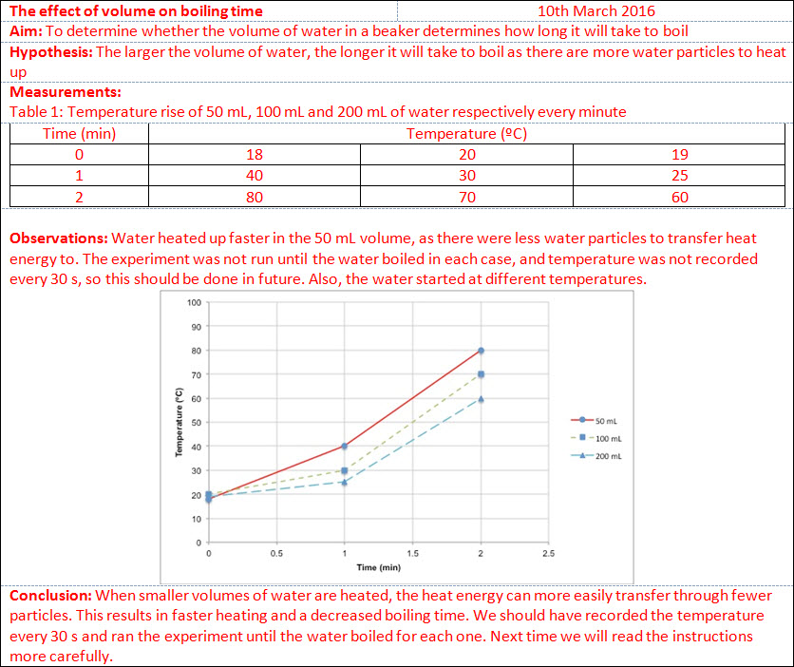1.5 Tables and graphs are used to present scientific data

Student worksheet answers (pages 12–13)

Graphing and interpreting data

1 What are the four features that all graphs have in common?

• Descriptive title of what the graph shows

• Grid that is used to plot the points or data

• Independent variable on the horizontal axis

• Dependant variable on the vertical axis

2 What is the most common type of graph used to represent data in science?

Line graph

3 What do the following graph shapes mean in terms of the dependant and independent variables?

a Positive slope upwards

Dependant variable increases as the independent variable increases

b Horizontal line

Dependant variable is not affected by the independent variable

c Negative slope downwards

Dependant variable decreases as the independent variable decreases

4 What is the name of the relationship when the data experiences

a a positive slope upwards?

Directly proportional relationship

b a negative slope downwards?

Inversely proportional relationship

5 A student reacted two chemicals together and recorded the temperature of the reaction for 8 minutes.

|  |  |
| --- | --- |
| **Time (mins)** | **Temperature (ºc)** |
| 0 | 20 |
| 1 | 30 |
| 2 | 40 |
| 3 | 50 |
| 4 | 60 |
| 5 | 65 |
| 6 | 68 |
| 7 | 69 |
| 8 | 70 |

a Create a line graph of the set of data that was obtained.

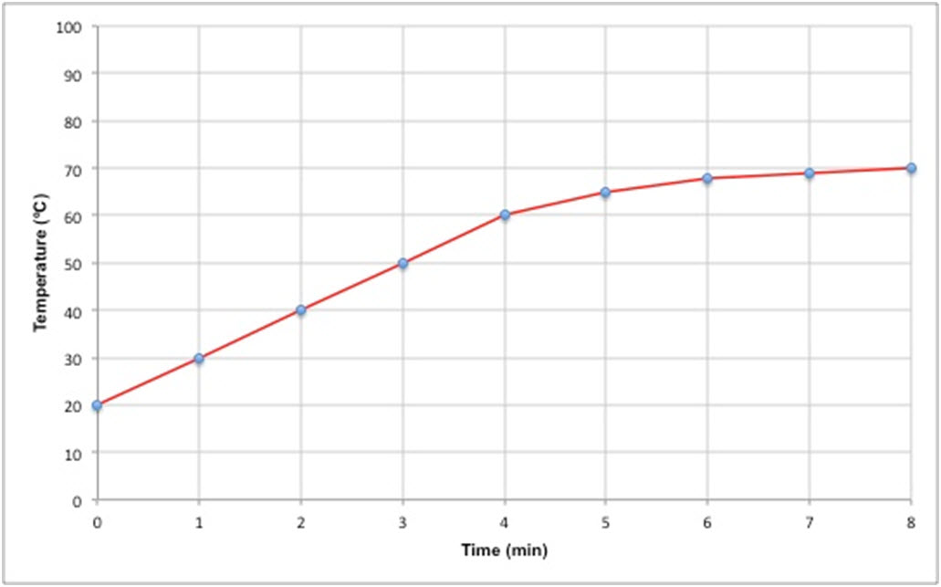

b What is the shape of the graph?

Positive slope upward, but not directly proportional as it starts to plateau

c What is the relationship between the independent variable and the dependant variable?

As time increases, temperature increases

Extend your understanding

Mathematics can often be used to determine the relationship between variables on a graph. For most graphs you can calculate the slope of the graph as .

6 A student wishes to test two methods of heating water. In the first method he uses a Bunsen burner, and in the second method he uses a hotplate.

a Graph the results of the two methods below.

|  |  |  |  |  |  |  |  |  |  |  |  |  |  |  |  |  |  |  |  |  |  |  |  |  |  |  |  |  |  |
| --- | --- | --- | --- | --- | --- | --- | --- | --- | --- | --- | --- | --- | --- | --- | --- | --- | --- | --- | --- | --- | --- | --- | --- | --- | --- | --- | --- | --- | --- |
| Bunsen burner   |  |  | | --- | --- | | **Time (min)** | **Temp (ºc)** | | 0 | 18 | | 1 | 34 | | 2 | 50 | | 3 | 66 | | 4 | 82 | | 5 | 98 | | Hotplate   |  |  | | --- | --- | | **Time (min)** | **Temp (ºc)** | | 0 | 18 | | 1 | 26 | | 2 | 34 | | 3 | 42 | | 4 | 50 | | 5 | 58 | |

b Using the graphs drawn in part a, calculate the slope of each graph.

Bunsen burner: Hotplate:

 

c Which heating method is more effective? Use your answers in part b to support your answer.

The Bunsen burner is more effective as it is able to heat the water at a faster rate. The slope of the line is steeper (16) as opposed to the hotplate (8), which means that the temperature will rise faster.